**A Project Report On**

**Explainable Machine Learning Framework for Stroke Prediction Using Risk Factor Analysis and Class Balancing Techniques**

***Major project submitted in partial fulfillment of the requirements for the***

***award of the degree of***

**BACHELOR OF TECHNOLOGY**

**IN**

**INFORMATION TECHNOLOGY**

**(2021-2025)**

**BY**

**J. KRISHNA CHAITANYA 21241A12F6**

**C. ABHINAV REDDY 21241A12D9**

**VINOD PAWAR 21241A12G4**

***Under the Esteemed Guidance***

***of***

**Dr. Y J Nagendra Kumar**

**Head of the Department**



**DEPARTMENT OF INFORMATION TECHNOLOGY**

**GOKARAJU RANGARAJU INSTITUTE OF ENGINEERING AND TECHNOLOGY**

**(AUTONOMOUS)**

**HYDERABAD**

**2024-25**

**CERTIFICATE**

This is to certify that it is a bonafide record of Major Project work entitled **“Explainable Machine Learning Framework for Stroke Prediction Using Risk Factor Analysis and Class Balancing Techniques”** done by **J. KRISHNA CHAITANYA (21241A12F6), C. ABHINAV REDDY (21241A12D9), VINOD PAWAR (21241A12G4)** of **B.Tech** in the Department of Information Technology, **Gokaraju Rangaraju Institute of Engineering and Technology** during the period 2021-2025 in the partial fulfillment of the requirements for the award of degree of **BACHELOR OF TECHNOLOGY IN INFORMATION TECHNOLOGY** from GRIET, Hyderabad.

**Dr. Y J Nagendra Kumar Dr. Y J Nagendra Kumar**

Head of the Department Head of the Department

(Internal Guide)

**(Project External)**



**ACKNOWLEDGEMENT**

We take the immense pleasure in expressing gratitude to our Internal guide**, Dr. Y J Nagendra Kumar, Head of the Department, IT**, **GRIET**. We express our sincere thanks for his encouragement, suggestions and support, which provided the impetus and paved

the way for the successful completion of the project work.

We wish to express our gratitude to **Dr. Y J Nagendra Kumar,** HOD IT,our Project Coordinators **G. Vijendar Reddy** and **K. Sandeep** for their constant support during the project.

We express our sincere thanks to **Dr. Jandhyala N Murthy,** Director, GRIET**,** and **Dr. J. Praveen,** Principal, GRIET**,** for providing us the conductive environment for carrying through our academic schedules and project with ease.

We also take this opportunity to convey our sincere thanks to the teaching and non-teaching staff of GRIET College, Hyderabad.



**Name:** J. Krishna Chaitanya **Name:** C. Abhinav Reddy

**Email**: chaitanyajuluri11@gmail.com **Email:** chilkuriabhinavr@gmail.com

**Contact No**: 8520046269 **Contact No**: 8639927360

**Name:** Vinod Pawar

**Email**: vinodpawar4069@gmail.com

**Contact:** 9121814860

**DECLARATION**

This is to certify that the major-project entitled “**Explainable Machine Learning Framework for Stroke Prediction Using Risk Factor Analysis and Class Balancing Techniques”** is a bonafide work done by us in partial fulfillment of the requirements for the award of the degree **BACHELOR OF TECHNOLOGY IN INFORMATION TECHNOLOGY** from Gokaraju Rangaraju Institute of Engineering and Technology, Hyderabad.

We also declare that this project is a result of our own effort and has not been copied or imitated from any source. Citations from any websites, books and paper publications are mentioned in the Bibliography.

This work was not submitted earlier at any other University or Institute for the award of any degree.

**J. KRISHNA CHAITANYA 21241A12F6**

**C. ABHINAV REDDY 21241A12D9**

**VINOD PAWAR 21241A12G4**

**TABLE OF CONTENTS**

|  | **Name** | **Page no** |
| --- | --- | --- |
|  | **Certificates** | 2 |
|  | **Contents** | 5 |
|  | **Abstract** | 5 |
| **1** | **INTRODUCTION** | 6 |
| 1.1  1.2  1.3 | Introduction to project  Motivation  Methodology | 6  8  9 |
| 1.4 | Existing System | 18 |
| 1.5 | Proposed System | 20 |
| **2** | **REQUIREMENT ENGINEERING** | 24 |
| 2.1 | Hardware Requirements | 24 |
| 2.2 | Software Requirements | 24 |
| **3** | **LITERATURE SURVEY** | 25 |
| **4** | **TECHNOLOGY** | 28 |
| **5** | **DESIGN REQUIREMENT ENGINEERING** | 35 |
| 5.1 | UML Diagrams | 35 |
| 5.2 | Use-Case Diagram | 36 |
| 5.3 | Class Diagram | 37 |
| 5.4 | Activity Diagram | 38 |
| 5.5 | Sequence Diagram | 39 |
| 5.6 | Architecture | 40 |
| **6** | **IMPLEMENTATION** | 41 |
| **7** | **SOFTWARE TESTING** | 50 |
| 7.1 | System Testing | 50 |
| 7.2 | Module Testing | 50 |
| 7.3 | Integration Testing | 50 |
| 7.4 | Acceptance Testing | 51 |
| **8** | **RESULTS** | 52 |
| **9** | **CONCLUSION AND FUTURE ENHANCEMENTS** | 54 |
| **10** | **BIBLIOGRAPHY** | 56 |

**11 LIST OF DIAGRAMS**

| **S No** | **Figure Name** | | **Page no** |
| --- | --- | --- | --- |
| **1** | Use Case Diagram | | 19 |
| **2** | Class Diagram | | 20 |
| **3** | Activity Diagram | | 21 |
| **4** | Sequence Diagram | | 22 |
| **5** | Architecture | | 22 |
|  | |
|  | |
|  | |

**ABSTRACT**

Stroke stands as a major international health issue because it causes both serious disability and death. Traditional approaches for early detection struggle to achieve accurate results and efficiency in patient outcome improvement. The study presents a stroke prediction approach based on machine learning that solves data imbalance issues with SMOTE and selects features using statistical approaches including Mutual Information Score with Chi-Square Score and ANOVA. Multiple machine learning models consisting of Random Forest, SVM, KNN, Logistic Regression and XGBoost in addition to Naïve Bayes achieved evaluation tests which produced a best performance level of approximately 91% accuracy. The interpretability of predictive systems improves through explainability methods SHAP and LIME which display essential risk factors that affect predictions so medical staff understand system outputs better. The developed Android application enables stroke risk assessment in real-time so predictive healthcare becomes more accessible to users. The study combines explainable machine learning methods with real-world deployment which supports prompt disease diagnosis and helps healthcare providers make better treatment choices.

**Keywords**: Stroke Prediction, SHAP, LIME, SMOTE, Random Forest, SVM, KNN, XGBoost, Logistic Regression, Naïve Bayes, Clinical Decision Support, Early Diagnosis.

**Domain**: Machine Learning, Deep Learning

**1. INTRODUCTION**

**1.1 Introduction to Project**

Stroke has emerged as one of the leading causes of death and disability worldwide, with its incidence steadily increasing over the past decades. According to the World Stroke Organization (WSO) Global Stroke Fact Sheet 2022, stroke accounts for the second-highest mortality rate and the third-largest cause of disability-adjusted life years (DALYs) lost globally [1]. The economic and healthcare burden of stroke is substantial, with lower- and middle-income countries (LMICs) experiencing the highest stroke-related mortality and disability rates. Early detection and intervention are crucial in preventing long-term complications and improving patient outcomes. However, traditional stroke prediction methods are often time-consuming and lack accuracy, necessitating the adoption of advanced computational techniques.

Recent advancements in machine learning (ML) have revolutionized stroke prediction by leveraging vast clinical datasets to identify high-risk individuals with greater precision. Studies have demonstrated that ML models can enhance early detection by analyzing various risk factors, including hypertension, diabetes, smoking, obesity, and genetic predisposition [3,6,7]. These predictive models offer significant advantages over conventional methods by providing real-time risk assessment, enabling clinicians to take proactive measures before a stroke occurs. Moreover, there is an increasing demand for explainable AI in healthcare, ensuring that ML-driven decisions are transparent and interpretable for medical professionals. The integration of explainability techniques such as SHAP (Shapley Additive Explanations) and LIME (Local Interpretable Model-Agnostic Explanations) enhances the credibility of AI-based stroke prediction by offering insights into the key contributing factors behind each diagnosis [4].

Stroke consequences reach beyond those who suffer from the condition by affecting both their domestic life and relationships with others while also disrupting their professional activities. General belief is mistaken because stroke affects people from any age range and medical condition background [2]. Stroke develops through sudden blockages or ruptures of brain blood supply which amounts to two major stroke types: ischemic strokes and hemorrhagic strokes. Arterial blockages together with vessel narrowing create reductions in oxygen supply that causes ischemic strokes which happen most often. The less frequent form of hemorrhagic stroke develops because a blood vessel ruptures which causes the brain to fill with internal bleeding [3]. Stroke as well as hemorrhagic stroke have variable effects on the brain that can result in temporary health problems and permanent disabilities. The main stroke risk factors stem from hypertension alongside diabetes while smoking serves as another factor accompanied by high cholesterol and obesity together with physical inactivity and blood clotting disorders in addition to cardiovascular conditions including atrial fibrillation and heart disease [5,6].

Stroke symptoms develop unpredictably and quickly and lead to such indications as paralysis in one body half and numbness in facial or limb territories and verbal communication issues and unsteadiness and visual blurring and headache occurrence and vomiting episodes and blacking out [8]. Waiting for medical care during a stroke onset becomes vital for preventing deadly secondary effects. The prompt recognition of symptoms by patients and their families and the subsequent emergency response presentation major obstacles for stroke management. Research findings demonstrate that people know stroke symptoms but they commonly delay calling for medical support which reduces treatment benefits and recovery outcomes [8].

Academic research groups have made stroke prediction models with artificial intelligence at their forefront to address healthcare challenges. The application of machine learning methods has led to predictions of stroke occurrences coupled with improved treatments and patient-specific rehabilitation planning. Multiple studies analyzed multiple Machine Learning techniques to achieve outstanding results in identifying strokes and making stroke classifications. The research team led by Arslan developed an SVM-based data mining system which processed clinical data from ischemic stroke subjects while delivering precision of 97.89% along with an AUC score reaching 97.83% [9]. Research on biomarker-based classification leads to successful differentiation of ischemic from hemorrhagic strokes providing rapid and specific stroke diagnosis possibilities [4].

The essential step for advancing stroke prediction and prevention involves uniting machine learning methods with clinical data analytics practices using explainable AI approaches because stroke-related medical problems are rapidly growing worldwide. The research aims to produce a dependable yet understandable machine learning system which accelerates stroke risk assessment besides facilitating prompt diagnosis and data-based clinical decision support. Through the power of AI this study tries to help lower deaths from strokes while improving medical services for patients and maximizing public health strategies.

**1.2 Motivation**

The interruption of brain blood flow during stroke causes neurological damage which leads to extended disability and frequently results in killing patients. Stroke has emerged as an increasing worldwide health matter because it creates substantial death rates while placing considerable financial strain on economies. WSO Global Stroke Fact Sheet 2022 reports stroke as the world's second deadliest medical condition and its impact causes substantial DALYs' loss worldwide [1]. The simultaneous occurrence of population aging and increasing numbers of hypertension patients and diabetic and obese persons fuels a steady rise in stroke vulnerabilities. The situation requires immediate awareness of early stroke detection methods and preventive measures to reduce its effects on people.

Systems used in predicting stroke often prove inefficient because they take too long and require substantial resources and produce unexpected results which keeps them limited for broad implementation. The application of stroke prediction models using machine learning technology allows healthcare providers to access accurate results from clinical and demographic information for fast treatment response. The primary goal of this study entails several essential achievements.

* Conduct development of a dependable machine learning model specifically intended to estimate stroke risk effectively.
* To deal with imbalanced stroke datasets with significant unbalanced rates of healthy subjects and stroke patients we will incorporate Synthetic Minority Over-sampling Technique (SMOTE) into the dataset [6].
* Risk factors that drive stroke occurrence will be determined through Mutual Information Score and Chi-Square Score and ANOVA tests to make models more interpretable [6].
* SHAP (Shapley Additive Explanations) and LIME (Local Interpretable Model-Agnostic Explanations) explainability techniques should be implemented to give clinicians detailed insights into predictions for evidence-based patient treatment decisions [4].
* A performance examination study should be conducted on Random Forest and SVM together with KNN and Logistic Regression as well as XGBoost and Naïve Bayes algorithms to establish the ideal stroke prediction solution [3,9].
* An Android application will serve as the basis for creating an end-to-end smart healthcare system which allows real-time stroke risk assessment to improve broad access to predictive healthcare solutions [7].

Different ML classifiers underwent comparative evaluation to define the model with best generalization ability and prediction accuracy which reached approximately 91% results. The study implemented explainable techniques to ensure transparency because it needed to overcome AI's interpretability problems in healthcare. The platform uses advanced predictive analytics together with interpretable AI systems to boost stroke detection speed and improve treatment methods which yields superior patient results.

This proposed model showcases strong potential to advance stroke care services while standardizing artificial intelligence healthcare operations and decreasing worldwide stroke impact through analysis-based medical solutions.

**1.3 METHODOLOGY**

The research project works toward creating an automated system for stroke prediction that relies on machine learning technology as it resolves operation challenges with real-time risk evaluation and explainable predictive models and unbalanced data conditions. A sequential pipeline for developing the solution includes data collection followed by preprocessing and feature selection followed by model training with explainability analysis before releasing it as a smart healthcare application.

**1. Data Collection & Preprocessing**

* Clinical and demographic risk factors represented by age, hypertension, diabetes, heart disease, BMI, smoking status and glucose levels form the dataset used in this study to predict strokes.
* The detected missing values received mean or mode-based imputation treatment following an analysis of attribute character.
* The numerical elements underwent normalization procedures while categorical elements received representation through combination of one-hot encoding and label encoding.

**2. Handling Class Imbalance**

* Stroke datasets lead to severe unbalanced data distribution since stroke cases remain much fewer than cases without stroke.
* When handling class imbalance in datasets the Synthetic Minority Over-sampling Technique (SMOTE) produced synthetic samples from the minority class which led to enhanced model accuracy along with a decrease in bias levels [6].

**3. Feature Selection**

* The approach used feature selection methods to find the most important predictive elements for model efficiency improvement.
* Mutual Information Score: Measures the dependency between stroke occurrence and each feature.
* Chi-Square Test: Identifies significant categorical features.
* ANOVA (Analysis of Variance) Test serves as a method to determine which numeric variables have the greatest impact on stroke prediction according to [6].

**4. Machine Learning Model Training & Evaluation**

* A set of multiple supervised learning methods were evaluated for stroke prediction through implementation.
* Random Forest
* Support Vector Machine (SVM)
* K-Nearest Neighbors (KNN)
* Logistic Regression
* XGBoost
* Naïve Bayes
* Evaluation of the models included measuring their accuracy together with precision and recall and F1-score and AUC-ROC scores.
* The model with highest accuracy of 91% could serve real-world applications for predicting strokes [3,9].

**5. Explainability & Model Interpretability**

* Explainability techniques became integrated into the system because machine learning models typically function as black boxes to establish clinician trust and model transparency.
* SHAP (Shapley Additive Explanations): Analyzes the impact of each feature on stroke prediction outcomes.
* LIME (Local Interpretable Model-Agnostic Explanations): Provides case-by-case explanations for individual predictions [4].
* By utilizing such techniques medical staff obtains visibility into how the system reaches a particular diagnosis which supports their choice-making process.

**6. Smart Healthcare System & Deployment**

* The stroke prediction model received its deployment as a mobile application because developers wanted to provide both user-friendly features together with accessibility.
* User-friendly application enables doctor-approved data entry of patient information.
* Real-time stroke risk assessment and probability score
* Such a system generates personal health suggestions which stem from the analysis of risk factors.
* Users can conduct remote stroke risk screenings through the application system that assists them in determining their risk status prior to medical consultation [7].

### Process Model Used with Justification

The project uses Software Development Life Cycle (SDLC) - Umbrella Model as its process structure.

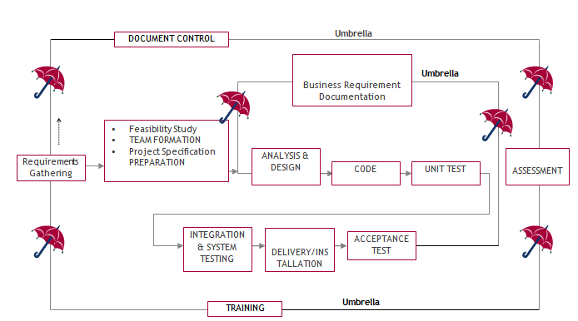

As a standard framework the Software Development Life Cycle (SDLC) serves the software industry to create dependable and efficient software solutions. This project depends on the Umbrella Model of SDLC for development due to its structured and iterative method which enables simple movement between phases. Every stage of this model delivers essential contributions toward the organized and efficient execution of the project.

**1. Requirement Gathering Stage**

The project foundation is established by this initial phase which determines essential functional as well as non-functional specifications.

The project aims are converted into measurable requirements which detail major system functions and operational data areas and reference data structures.

***Deliverables:***

* A Requirements Document provides comprehensive descriptions of every requirement which has been discovered during identification.

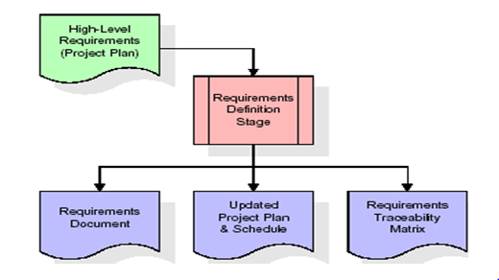

* Through Requirements Traceability Matrix (RTM) the project heritage of all requirements gets followed during their entire lifecycle.
* During this phase the organization ensures complete scope definition to prevent later confusion and misunderstandings.

**2. Feasibility Study & Team Formation**

Organizations conduct feasibility studies to discover possible obstacles that influence project feasibility ratings.

The team formation process launches when employees receive particular assignments according to their expertise.

Adminstrators must maintain the system inputs and outputs along with generation and distribution of specified reports based on project specifications.

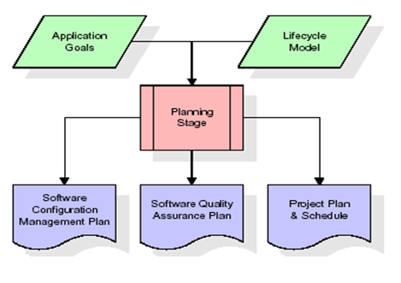

**3. Analysis Stage**

Through planning the project obtains a general view which outlines its design and determines how feasible it is and what potential risks exist.

The main purpose involves defining software necessities which must correspond to organizational targets.

***Deliverables:***

* Configuration Management Plan
* Quality Assurance Plan
* Project Plan & Schedule

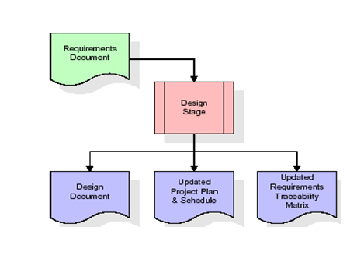

**4. Designing Stage**

During the design phase the approved requirements become structured design components.

This includes:

* Functional hierarchy diagrams
* Screen layout diagrams
* Entity-relationship (ER) diagrams
* Pseudocode for core logic implementation

***Deliverables:***

* A finalized design document.
* An updated RTM connects requirements with design elements to form a direct link between them.

**5. Development (Coding) Stage**

Working software components emerge from converting design elements in the development phase.

Development of software artifacts creates menus along with dialog boxes and data reporting formats and specialized functions.

Testing teams use each developed component as a basis to validate its linked test cases.

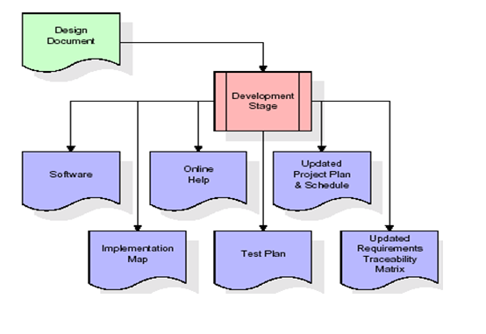

***Deliverables:***

* Fully functional software components.
* A test plan covering validation procedures.
* An updated RTM and project plan.

**6. Integration & Testing Stage**

Software developers perform extensive testing of the developed product in a test environment to confirm its exactness and satisfy both fullness and dependability standards.

***Key Activities:***

* The execution of predefined test cases reveals the systems accuracy.
* Transfer of testing data occurs to an isolated environment for assessment purposes.
* Finalizing production reference data

***Deliverables:***

* Integrated software system.
* Production initiation plan.
* Acceptance test suite.

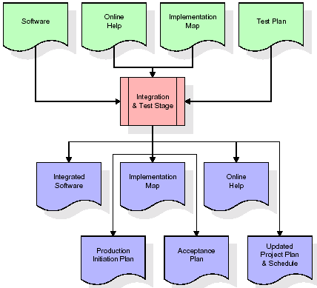

**7. Installation & Acceptance Testing**

The testing phase involves moving the application into a real production system where acceptance tests proceed afterward.

Customer validation ensures that:

The software functions as expected.

The first set of production data entered into the system during load operations shows complete accuracy.

The test suite runs successfully.

After getting project approval it becomes an official part of the archive system as reference material.

***Deliverables:***

* Fully deployed production application.
* Signed customer acceptance memorandum.

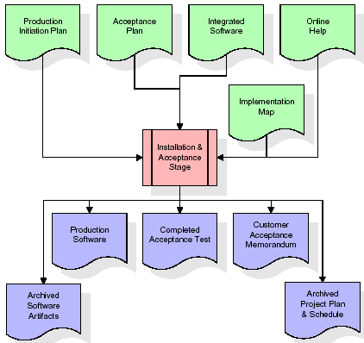

**8. Maintenance Phase**

The maintenance phase comprises an unending cycle according to the umbrella model.

***Activities include:***

* End users may trigger modifications to system requirements.
* Bug fixes and performance optimizations.
* The model operation continues indefinitely which determines its name "Umbrella" and supports enduring software operation longevity.

**Justification for Using the Umbrella Model**

* A methodical approach guarantees that every stage inside this model operates with clarity and proper connection points.
* The RTM provides a pathway for documenting requirements at every development phase which reduces the occurrence of conflicting information.
* Risk Mitigation occurs because a feasibility study reveals potential risks for early identification and prevention.
* Continuous Maintenance features allow the Umbrella Model to conduct long-term software enhancements which boost system adaptability throughout its operational period.
* A systematic development framework produces high-quality maintainable products which meet project needs by handling actual health care difficulties.

**1.4 Existing System**

The existing approach to stroke prediction in clinical settings primarily relies on manual assessments carried out by healthcare professionals, based on a patient's medical history, physical examination, and a set of standard diagnostic tests. These conventional methods often depend on physician experience and judgment, which, while valuable, are subject to variation between practitioners. In many cases, stroke prediction is performed reactively—once a patient exhibits symptoms—rather than proactively identifying individuals at risk before a stroke occurs.

Another limitation is the absence of automation and intelligent data analysis. While basic electronic health records (EHRs) may be used, they are not typically integrated with predictive models or algorithms capable of analyzing complex relationships among various clinical and lifestyle factors. As a result, the ability to detect early warning signs is significantly reduced.

Furthermore, these systems do not support real-time risk assessment. In rapidly evolving clinical situations, delayed or inaccurate diagnosis can result in missed opportunities for timely intervention. The lack of explainability in the existing decision-making process also poses challenges, as neither patients nor clinicians can fully understand or trace how a risk level is determined unless it is based purely on predefined checklists.

Lastly, existing systems are not scalable or personalized. They fail to consider individual-specific variations in risk factors, such as the interaction of age, genetic history, and lifestyle habits, limiting their applicability across diverse populations.

**Drawbacks of the Existing System**:

1. **Labor-intensive and costly**: Manual assessment requires significant physician time and resources, making it inefficient for large-scale or public healthcare systems.
2. **Inconsistent and error-prone**: Diagnosis accuracy varies due to subjective human interpretation.
3. **Delayed diagnosis**: Lack of automation leads to missed opportunities for early intervention.
4. **Limited data analysis**: Inability to process and interpret large-scale, multi-dimensional data for accurate risk prediction.
5. **No real-time prediction capability**: Patients must wait for appointments and lab results, delaying critical care.
6. **Lack of explainability**: Clinicians and patients receive no clear justification for how decisions are made, lowering trust and usability.
7. **Not scalable**: Ineffective for deployment in mass-screening programs or regions with limited access to specialists.

**1.5 Proposed System**

The proposed system leverages the power of machine learning (ML) and explainable artificial intelligence (XAI) to offer a modern, data-driven solution for stroke prediction. By analyzing key clinical indicators such as age, hypertension, diabetes, heart disease, BMI, smoking status, and glucose levels, the system is capable of predicting stroke risk with high accuracy (up to 91%). This provides a proactive approach to stroke prevention, shifting the focus from treatment to early intervention.

One of the major strengths of the proposed system is its automation and cost-efficiency. Unlike manual assessment, it can evaluate thousands of records in seconds, making it highly suitable for large-scale deployment, such as national screening programs or hospital networks. The use of SMOTE ensures balanced datasets, improving model fairness and reliability.

Moreover, the system incorporates explainability tools like SHAP and LIME, offering clear, human-readable explanations of how specific factors contribute to a patient's risk score. This builds trust and transparency, enabling healthcare professionals to make informed decisions and helping patients understand their own health better.

Another key benefit is the integration of the model into a user-friendly Android application, providing real-time, accessible stroke risk assessments directly to users. This is especially beneficial in rural and underserved areas, where access to medical specialists may be limited.

#### Advantages of the Proposed System

1. **High prediction accuracy** (up to 91%) using advanced machine learning techniques.
2. **Automation and scalability**: Capable of processing large datasets quickly, reducing labor and cost in healthcare operations.
3. **Real-time risk assessment**: Enables early intervention and preventive care without waiting for physical consultations.
4. **Explainable AI**: SHAP and LIME offer interpretable insights, improving decision-making and clinician-patient trust.
5. **Cost-effective**: Reduces the need for labor-intensive evaluations and manual diagnostics.
6. **Personalized risk profiling**: Takes into account individual health conditions, habits, and demographic factors.
7. **Mobile accessibility**: The integrated Android application makes the system widely usable and available on-the-go.
8. **Adaptable to diverse populations**: Can be extended to various clinical settings and demographic groups.

Overall, the proposed system transforms stroke risk prediction from a slow, manual process into a smart, scalable, and transparent solution for modern healthcare.

**Key Components of the Proposed System**:

The proposed stroke prediction system is designed to be a comprehensive, intelligent, and explainable solution that supports early diagnosis and intervention. It integrates multiple technologies and methodologies to ensure accuracy, transparency, and accessibility. The key components of this system are outlined below:

#### *1. Preprocessed and Balanced Dataset*

* The system uses a well-structured dataset consisting of 5,110 records with 12 features, including both numerical and categorical attributes such as age, hypertension, glucose levels, and smoking status.
* To handle the class imbalance (where stroke cases are significantly fewer than non-stroke cases), the Synthetic Minority Over-sampling Technique (SMOTE) is applied. This ensures that the model is not biased toward the majority class and performs well on underrepresented stroke cases.

#### *2. Feature Selection Module*

* To improve model efficiency and reduce noise, the system employs feature selection techniques:
  + Mutual Information Score
  + Chi-Square Test
  + ANOVA (Analysis of Variance) Test
* These techniques help identify the most relevant features contributing to stroke prediction, enhancing both accuracy and interpretability.

#### *3. Machine Learning Models*

* A variety of machine learning algorithms are implemented and compared to identify the best-performing model. These include:
  + Random Forest
  + Support Vector Machine (SVM)
  + K-Nearest Neighbors (KNN)
  + Logistic Regression
  + XGBoost
  + Naïve Bayes
* The selected model, achieving an accuracy of approximately 91%, is used as the final predictive engine.

#### *4. Explainable AI (XAI) Framework*

* To ensure transparency and trust in predictions, the system incorporates Explainable AI techniques, including:
  + SHAP (Shapley Additive Explanations) – Provides global and local interpretations of feature impact on predictions.
  + LIME (Local Interpretable Model-Agnostic Explanations) – Offers case-specific explanations for individual predictions.
* These components allow clinicians to understand the reasoning behind predictions, facilitating informed medical decisions.

#### *5. Evaluation and Metrics Module*

* The model’s performance is rigorously evaluated using standard metrics such as:
  + Accuracy, Precision, Recall, F1-Score, and AUC-ROC
* A confusion matrix is also used to analyze false positives and false negatives, ensuring model robustness and reliability.

#### *6. Android Application (End-to-End Deployment)*

* The final model is integrated into a user-friendly Android application that allows users (patients or clinicians) to:
  + Input patient data through a simple interface
  + Instantly receive stroke risk predictions
  + View explainable insights on contributing risk factors
* This makes the system accessible in real-time and especially useful in remote or underserved regions.

#### *7. Real-Time Decision Support Capability*

* The system acts as a Clinical Decision Support System (CDSS) by delivering stroke risk assessments in real time.
* This component empowers healthcare professionals to act proactively before severe symptoms manifest, improving patient outcomes.

**2. REQUIREMENT ENGINEERING**

**2.1 Hardware Requirements**

* Processor – i5 and above (64-bit OS).
* Memory – 4GB RAM (Higher specs are recommended for high performance)
* Input devices – Keyboard, Mouse

**2.2 Software Requirements**

* Anaconda Navigator/Jupiter Notebook
* Python
* Python Libraries : TensorFlow

Keras

OpenCV

NumPy

Matplotlib

CSV

Pandas

SKlearn

Imblearn

Shap

Lime

**3. LITERATURE SURVEY**

**[1] World Stroke Organization (WSO): Global Stroke Fact Sheet 2022**

WSO statistics indicate stroke stays positioned as the second major cause of mortality worldwide followed by being third regarding DALYs lost. Stroke incidence rates grew by 70% throughout the period of 1990 to 2019 and stroke-related deaths increased by 43% and overall stroke prevalence reached a 102% escalation. The worldwide financial healthcare costs of stroke exceed $721 billion while LMICs bear the maximum stroke-related burdens. To decrease both stroke-related deaths and disability it becomes essential to develop early detection systems and preventive strategies as soon as possible.

### [2] The Relationship Between Social Support and Participation in Stroke: A Systematic Review

### Researchers used Ebscohost with Science Direct in addition to Biomed Central and Cochrane Library and Pedro Central and the combination of Google Scholar and Wiley Online to conduct a systematic review about social support effects on post-stroke recovery. Strong support networks lead to enhanced rehabilitation results which causes individuals to become more involved in social events along with occupational tasks according to study findings. The study shows that stroke management programs should include social support interventions to improve patient outcomes during recovery.

### [3] Global Burden of Stroke

### Arsalan et al. studied stroke epidemiology and established that ischemic strokes occur more frequently and homic strokes produce greater death numbers. The research results showed that hypertension and diabetes and smoking and obesity function as main risk variables which control stroke development. The study authors stated that developing countries need prevention programs alongside better health care access to combat the increasing rate of strokes.

### [4] Blood Biomarkers to Differentiate Ischemic and Hemorrhagic Strokes

### The research team of John et al. evaluated blood markers for identifying between individuals who suffered from ischemic stroke (IS) and those affected by intracerebral hemorrhage (ICH). This research confirmed the validity of a biomarker panel which included Glial Fibrillary Acid Protein (GFAP), Retinol Binding Protein 4 (RBP-4) in combination with N-terminal proB-type natriuretic peptide (NT-proBNP). These biomarkers yielded high specificity levels in stroke subtype classification when used as a combined approach in clinical diagnosis.

### 

### [5] Prevalence and Risk Factors of Stroke in the Elderly in Northern China

Data from the National Stroke Screening Survey Liu et al. performed a broad stroke surveillance survey throughout China to examine prevalence together with risk factors within the senior population (age 60 and above). The research determined a 4.94% prevalence rate of stroke with hypertension standing as the leading risk factor. Gender disparities were discovered in the study data since women had higher diabetes and obesity numbers and men bore elevated smoking and alcohol statistics. While the study reported that urban-rural inequalities existed between stroke population risks and healthcare delivery systems in China.

**[6] Hypertension and Diabetes Mellitus as Predictive Risk Factors for Stroke**

Research by Smith et al through meta-analysis established hypertension alongside diabetes mellitus as principal stroke risk elements. The research stressed that prompt detection and proper management of these diseases helps decrease stroke-related burdens. Medical personnel recognize lifestyle adjustment as a leading stroke prevention approach by working on diet change and physical activity and smoking cessation practices.

**[7] Genetic and Environmental Influences on Stroke**

Brown et al. researched how both genetic background and environmental conditions affect stroke development in their research. The analysis divided stroke risk elements between factors that patients can change (hypertension, smoking, obesity) and fixed characteristics (age, gender, ethnicity). Stroke prevention through personalized medicine requires an understanding of genetic mutations because they determine stroke susceptibility according to this study.

**[8] This systematic review examined the situation regarding UK patient stroke public education and emergency reaction progress.**

Anderson et al. examined UK public knowledge about stroke symptoms together with emergency response duration through their study. The research demonstrated that people in the general public demonstrated strong knowledge about stroke signs including unilateral weakness along with speech problems yet displayed limited understanding of the need for immediate medical intervention. The researchers proposed that all individuals require nationwide awareness campaigns for stroke in order to enhance both early medical response time and stroke patient care.

**[9] The Differential Diagnosis of Suspected Stroke: A Systematic Review**

The study by Williams et al. examined how well healthcare providers diagnosed stroke cases throughout ambulance services and primary care units as well as emergency departments. The research established that 74% of cases which medical professionals suspected to be strokes turned out to be stroke incidents while other patients received incorrect diagnoses that included seizures, syncope and brain tumors. The research data demonstrated that improved diagnostic procedures must be implemented because they would lower instances of mistaken stroke diagnosis for correct therapeutic measures.

**4. TECHNOLOGY**

**4.1 ABOUT PYTHON**

Python's environment has evolved significantly, enhancing its capabilities for statistical analysis. It strikes a fine balance between scalability and elegance, placing a premium on efficiency and code readability. Python is renowned for its emphasis on program readability, featuring a straightforward syntax that is beginner-friendly and encourages concise code expression through indentation. Noteworthy aspects of this high-level language include dynamic system functions and automatic memory management.

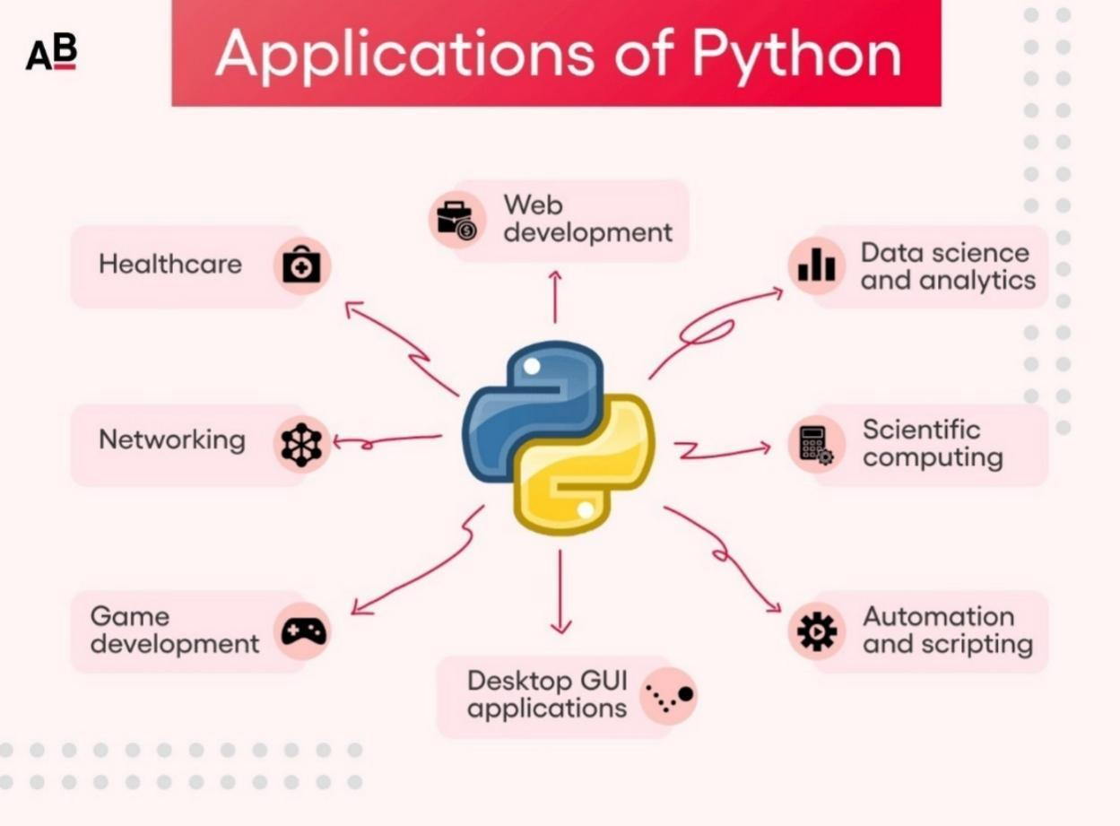

**4.2 APPLICATIONS OF PYTHON**

Python is used in many application domains. It makes its presence in every emerging field. It is the fastest-growing programming language and may be used to create any type of application.

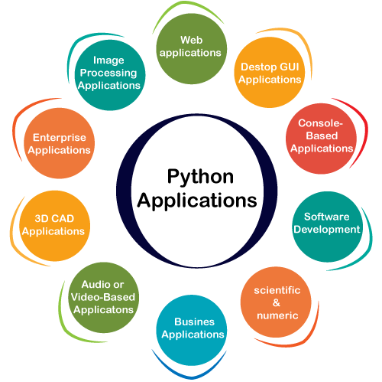

Applications of python

It is used in various fields:

* Web Applications. We can use Python to develop web applications. ...
* Desktop GUI Applications. ...
* Console-based Application. ...
* Software Development. ...
* Scientific and Numeric. ...
* Business Applications. ...
* Audio or Video-based Applications. ...
* 3D CAD Applications.

**4.3 PYTHON IS WIDELY USED IN MACHINE LEARNING**

Python is widely favored in machine learning for its flexibility and open-source nature. It provides extensive functionality for mathematical computations and scientific operations, making it indispensable in developing and deploying machine learning models. Python's simple syntax and vast libraries accelerate the development process, reducing coding time significantly. This makes it a preferred choice for machine learning practitioners seeking efficiency and robustness in their projects.

The major Python libraries used in machine learning are as follows:

**4.3.1 TENSOR FLOW**

TensorFlow is an open-source deep learning framework developed by Google, widely used for machine learning and AI applications. It provides powerful tools for building and training neural networks, enabling both high-level operations and detailed customization. Known for its scalability, TensorFlow can run on multiple platforms, including CPUs, GPUs, and TPUs, making it versatile for various applications. It’s especially valuable for image recognition tasks, such as in this project, where it helps train the CNN model to accurately classify fresh and rotten fruits.

**4.3.2 NUMPY**

NumPy is a Python library utilized for numerical data reading, cleaning, exploration, and manipulation. It provides powerful data structures for efficient computation with large arrays and matrices, making the data more accessible and manageable.

**4.3.3 KERAS**

Keras is a high-level neural networks API written in Python, designed for easy and fast experimentation with deep learning models. It runs on top of frameworks like TensorFlow, providing a user-friendly interface for building and training neural networks. Keras is widely used for its simplicity and flexibility, making it ideal for prototyping complex models quickly.

**4.3.4 OPEN CV**

OpenCV (Open Source Computer Vision Library) is a comprehensive open-source library aimed at real-time computer vision applications. It offers a vast range of tools for image processing, video analysis, and computer vision tasks like object detection and face recognition. OpenCV is widely used in fields like robotics, image analysis, and artificial intelligence due to its efficiency and extensive functionalities.

**4.3.5 CSV**

It is a kind of file that stores tabular records, like a spreadsheet or a database. There are one or extra fields in each entry, that are separated by commas. We use the csv built in module to work with CSV files.

**4.3.6 MATPLOTLIB**

Matplotlib is a powerful Python library for data visualization, allowing users to create a wide range of static, animated, and interactive plots. It provides flexibility in plotting line graphs, histograms, scatter plots, and more, making it a valuable tool for data analysis and scientific research. Matplotlib is widely used in conjunction with libraries like NumPy and pandas for visualizing complex data and results.

**4.3.7 INTERPRETED LANGUAGE**

Python executes code line by line, without the need for prior compilation. This approach facilitates quicker development cycles and simplifies the debugging process. As a result, developers can iterate and test their code more efficiently.

#### 4.3.8 PANDAS

#### Pandas is a versatile data analysis library that provides data structures like DataFrames and Series for handling structured data. It was used extensively in this project for reading the dataset, handling missing values, encoding categorical data, and organizing the features for training machine learning models.

#### 4.3.9 SCIKIT-LEARN (sklearn)

Scikit-learn is a comprehensive machine learning library used for implementing a wide range of algorithms and tools. It was used in this project for:

* Data splitting (train-test)
* Model training and evaluation (Logistic Regression, SVM, Random Forest, KNN, Naïve Bayes)
* Feature selection techniques (Chi-Square, ANOVA, Mutual Information)
* Metrics computation (Accuracy, Precision, Recall, F1-Score, AUC-ROC)
* Data preprocessing and SMOTE integration

#### 4.3.10 IMBALANCED-LEARN

Imbalanced-learn is an extension of scikit-learn that specifically deals with imbalanced datasets. In this project, it was used to implement the Synthetic Minority Over-sampling Technique (SMOTE), which balances the dataset by generating synthetic examples of the minority class (stroke cases).

#### 4.3.11 XGBOOST

XGBoost is an optimized gradient boosting framework used for high-performance model training. It was implemented as one of the classifiers in this project due to its efficiency and superior accuracy, especially in structured datasets.

#### 4.3.12 SHAP (Shapley Additive Explanations)

SHAP is a specialized library for explainable AI, offering global and local interpretability of model predictions. It was used in this project to visualize how each feature contributed to a specific stroke prediction, enhancing transparency and trust in the model.

#### 4.3.13 LIME (Local Interpretable Model-Agnostic Explanations)

LIME is another explainability tool used for interpreting individual predictions by approximating the black-box model with a simpler, interpretable model. It helped provide case-specific explanations to understand the behavior of the classifier for a given input.

**4.4 Dataset Description**

The research bases its analysis on 5,110 patient records which include thirteen essential attributes that characterize both age-related and health-related stroke prediction aspects. The collection includes features of both categorical and numerical types to generate an extensive representation of patient characteristics.

The data collection functions as the base to develop machine learning models which assess stroke prediction capabilities. The study integrates multiple factors including age group in combination with hypertension, heart disease, glucose measurements and the body mass index as well as smoking profiles and employment and residential classification. The identified variables create essential components for identifying stroke risks while supporting quick detection efforts.

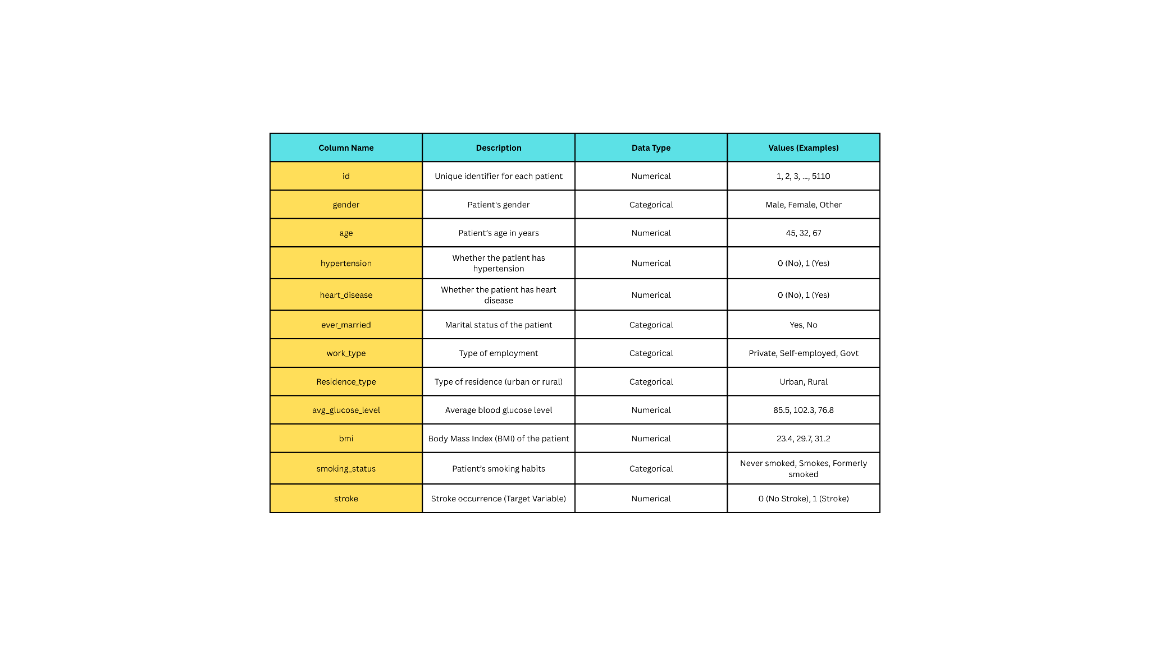The details of the dataset are summarized in the following table:

***Data Type Classification***

**Numerical Features:**

The dataset contains age and data regarding hypertension, heart disease, average glucose level, body mass index and stroke.

**Categorical Features:**

gender, ever_married, work_type, Residence_type, smoking_status

The dataset contains a stroke target variable that distinguishes patients who have had a stroke (1: Stroke, 0: No Stroke). The dataset offers an optimal balance of categorical and numerical features to support machine learning stroke prediction models capable of performing risk assessment together with classification tasks.

Preprocessing the data requires techniques that include feature scaling and both categorical encoding and class balancing in order to optimize the dataset for predictive modeling. The positive impact from this research would enable medical staff to detect high-stroke risk patients efficiently while delivering prompt medical care.

**5.DESIGN REQUIREMENT ENGINEERING**

**Concept of uml:**

The purpose of these UML-based diagrams is to visually depict the system, including its key components, roles, operations, objects, or interactions. This visual representation aims to enhance understanding, facilitate manipulation, and effectively document or manage system-related information.

**UML DIAGRAMS:**

The Unified Modeling Language (UML) serves as a standardized language for creating models across various domains. Its primary goal is to visually represent the structure of a system, akin to blueprints in engineering disciplines. In complex applications involving multiple teams, clear communication is crucial, especially to stakeholders who may not be familiar with programming code. UML facilitates this communication by illustrating essential system requirements, features, and processes in a visual manner. By depicting processes, user interactions, and the system's 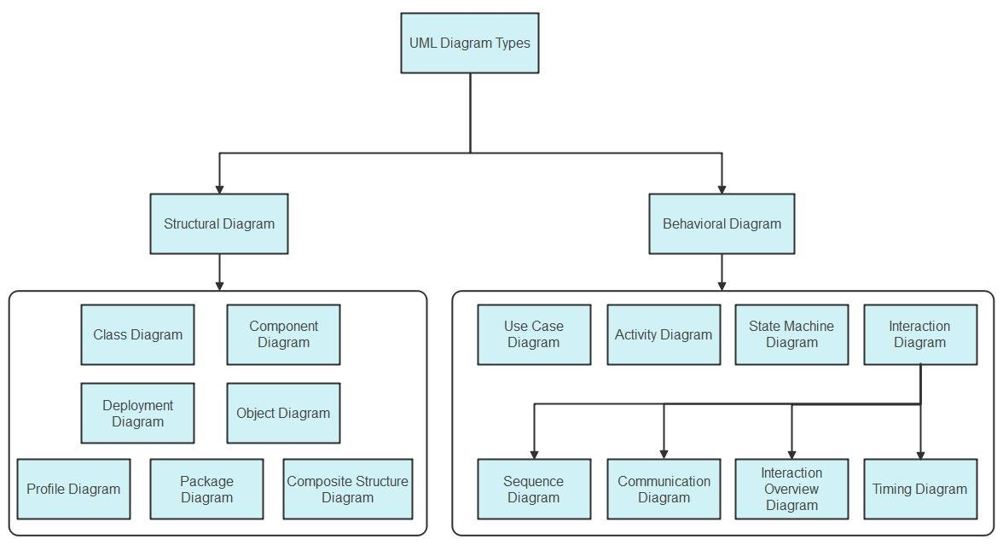static structure, UML helps teams streamline collaboration and optimize efficiency.

**Concepts of uml**

**5.1 Use case Diagram:**

A use case diagram is a type of behavioral diagram that is a graphical explanation of the functionalities offered by the system in relation to the participants, their goals, and any dependencies between these cases.

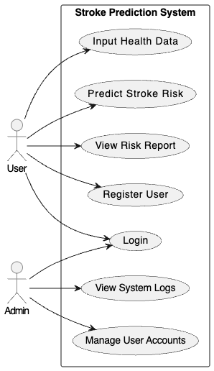

Use Case Diagram

**5.2 Class Diagram:**

A class diagram is a static type of structural diagram that still depicts the format of a machine by means of illustrating the hyperlinks among the machine's lessons, attributes, operations, and instructions.

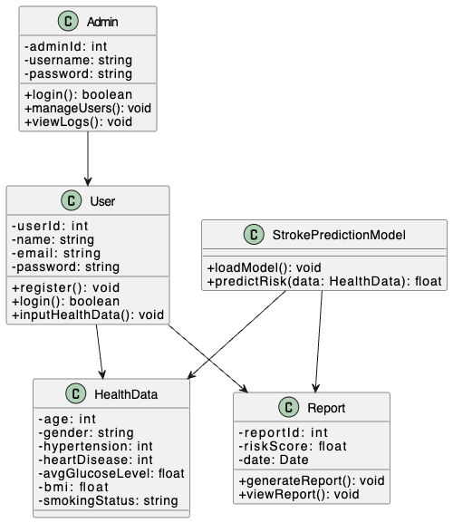

Class Diagram

**5.3 Activity diagram:**

This diagram is a more complex version of a flow chart that depicts the flow of information from one activity to the next. It describes the coordination of activities in order to offer a service at various levels of abstraction.

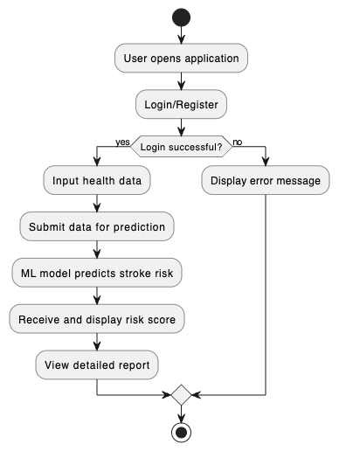

Activity Diagram

**5.4 Sequence Diagram:**

The deployment diagram of our machine in order to define distinct states of an object for the duration of its lifetime. It usually suggests how the kingdom of an object adjusts in its lifetime. 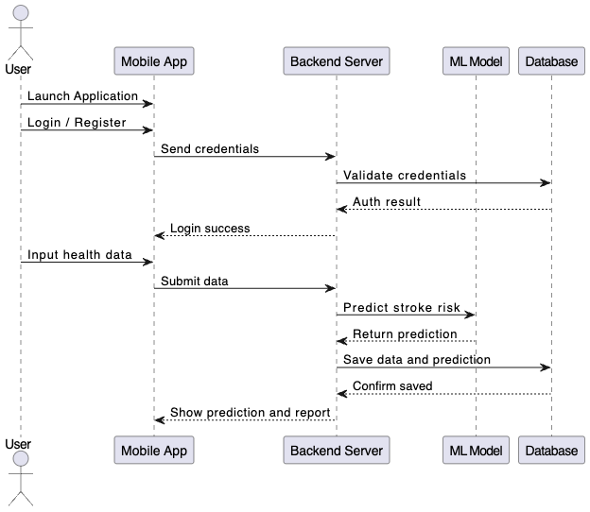

Sequence Diagram

**5.5 System Architecture Diagram**

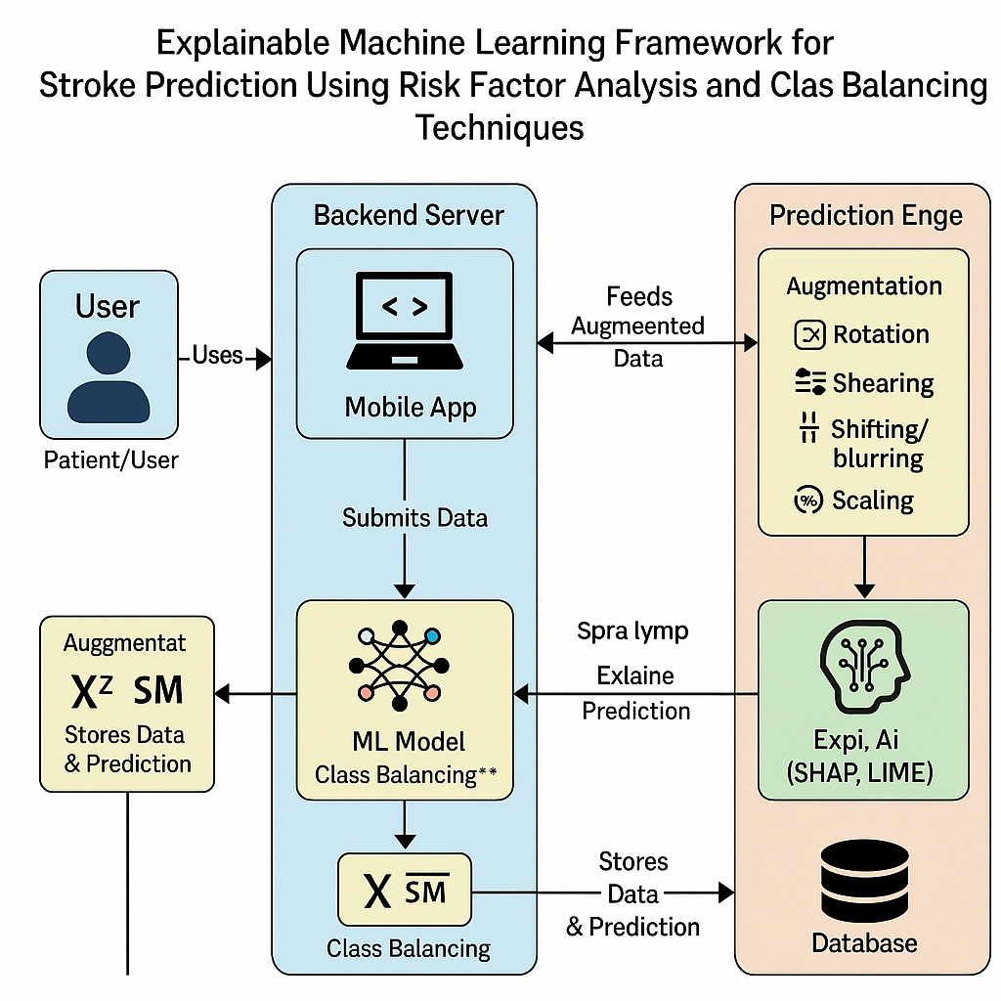

Architecture Diagram

**6. IMPLEMENTATION**

Stroke often causes due to blood flow stop to brain and this is one of the deadly diseases. Patient life can be saved and stroke can be avoided by timely and accurate detection. Existing detection technique requires heavy resources and they make time for prediction. To overcome from this problem many machine learning algorithms were introduced as they are very accurate in medical diseases prediction but existing techniques were suffering from data leakage such as improper handling or missing values, improper categorical data calculation etc. No existing techniques were employing any Explainable model (XAI) which can show which features are helping most in detecting stroke so doctor can give priority on such features for faster recovery. These explainable features can be Smoking, Age, BMI and may be other features.

So author of this paper employing different processing techniques such as Removing missing values, Imbalance data handling using SMOTE and relevant features selection using CHI2 algorithm. All this processed features will get trained on 6 different algorithms such as Random Forest, KNN, SVM, Logistic Regression, XGBOOST and Naive Bayes. In all algorithm Random Forest is giving high accuracy and each algorithm performance is evaluated in terms of accuracy, precision, recall and FSCORE.

For easy understanding of features author employing various graph on Strokes patient data. Best algorithm will be input to SHAPELY Explainable (XAI) algorithm to explain about features which are contributing most in predicting correct label.

To train all algorithms we are using STROKE dataset from KAGGLE and below screen showing all dataset details

In above screen first row represents dataset column names and remaining rows represents dataset values and by using above dataset we will test all algorithm performance.

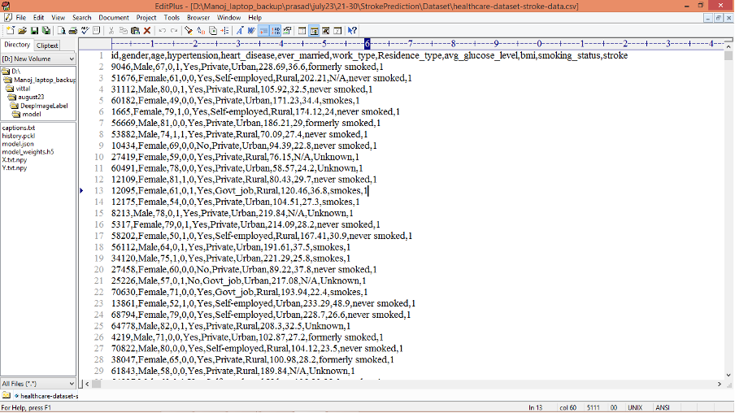

In above screen first row represents dataset column names and remaining rows represents dataset values and by using above dataset we will test all algorithm performance.

Extension Concept

As extension we are employing CATBOOST classifier which will use forest of weak classifiers or group of multiple classifiers and then train each classifier and vote out best classifier for final prediction and using multiple classifier will help CATBOOST in enhancing prediction accuracy.

To run project double click on ‘run.bat’ file to get below screen

In above screen, click on upload button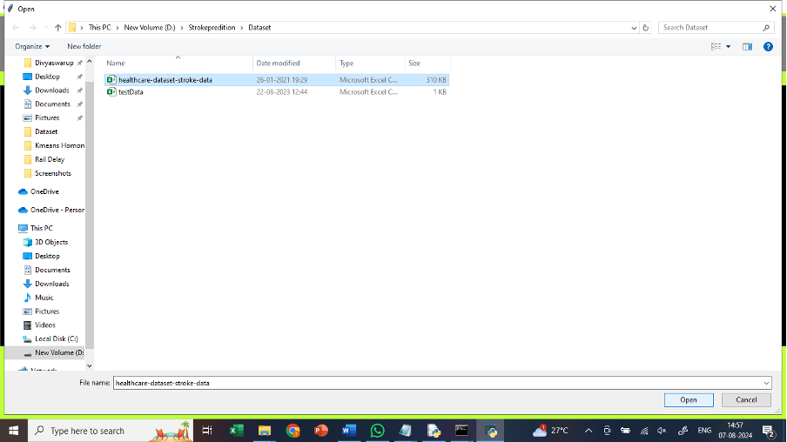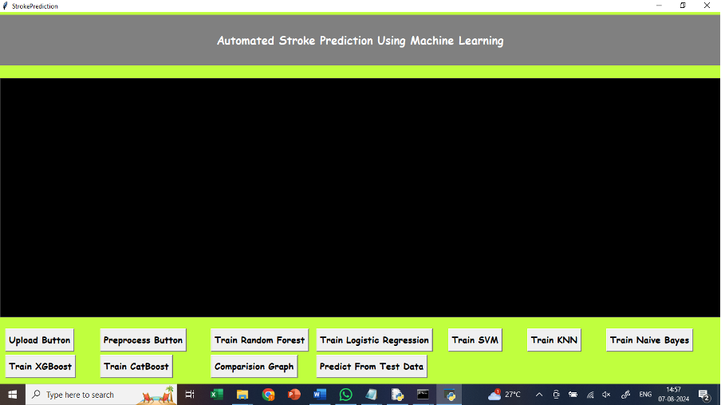

In above screen, upload healthcare dataset

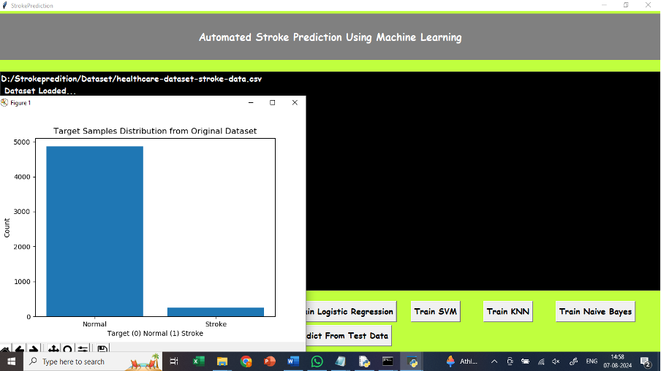

In above screen, we are getting the graph which displays the data related to normal and stroke.

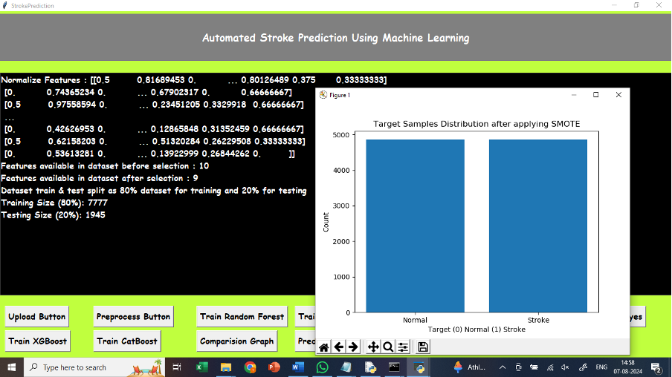

In above screen, click on preprocess button, for splitting the dataset, 80% for training and 20% for testing.

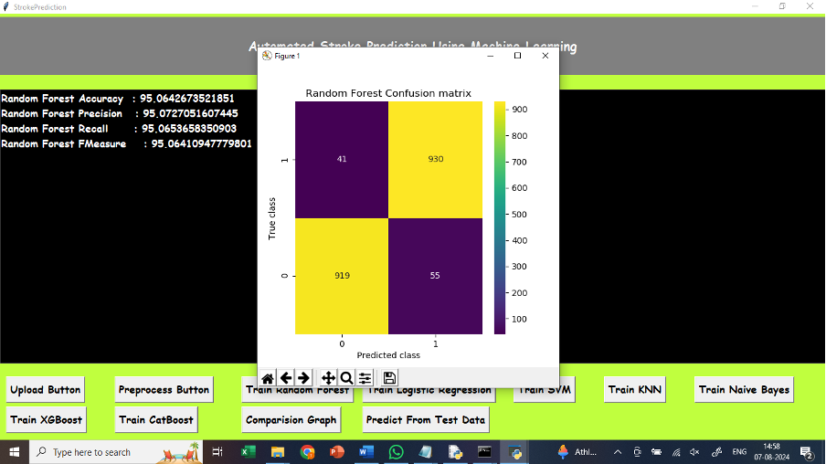

In above screen, click on Train Random Forest button, to train Random Forest and got 95% accuracy. In confusion matrix graph x-axis represents Predicted Labels and y-axis represents True Labels where blue boxes represents incorrect prediction count which are very few and yellow and light green boxes represents correct prediction count.

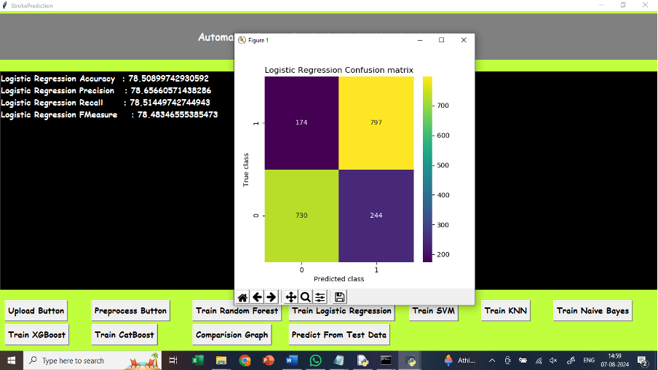

In above screen, click on Train Logistic Regression button, to train Random Forest and got 78% accuracy. In confusion matrix graph x-axis represents Predicted Labels and y-axis represents True Labels where blue boxes represents incorrect prediction count which are very few and yellow and light green boxes represents correct prediction count.

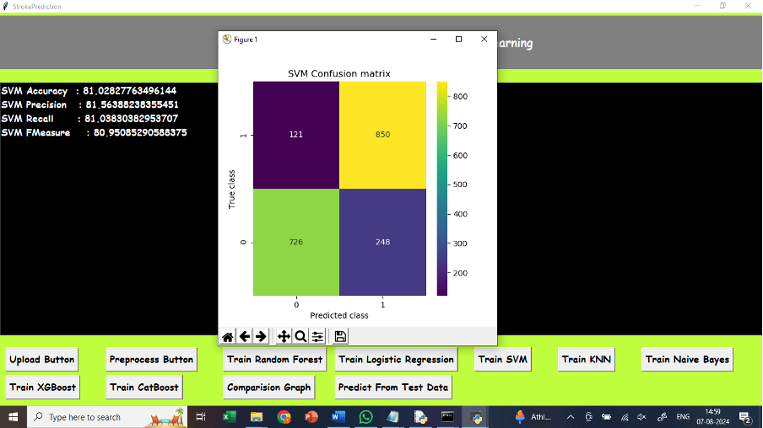

In above screen, click on Train SVM button, to train SVM and got 81% accuracy. In confusion matrix graph x-axis represents Predicted Labels and y-axis represents True Labels where blue boxes represents incorrect prediction count which are very few and yellow and light green boxes represents correct prediction count.

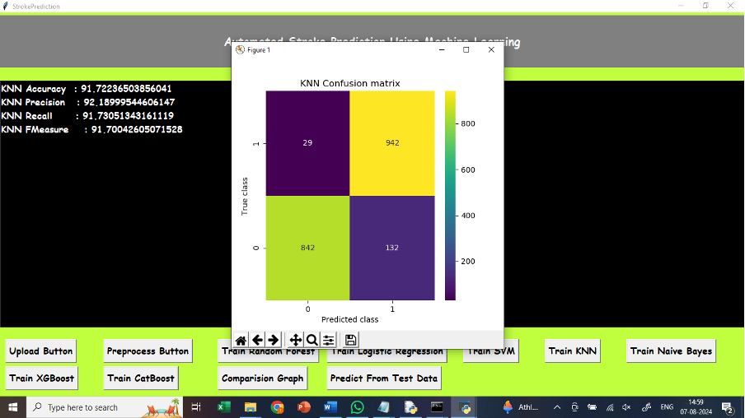

In above screen, click on Train KNN button, to train KNN and got 91% accuracy. In confusion matrix graph x-axis represents Predicted Labels and y-axis represents True Labels where blue boxes represents incorrect prediction count which are very few and yellow and light green boxes represents correct prediction count.

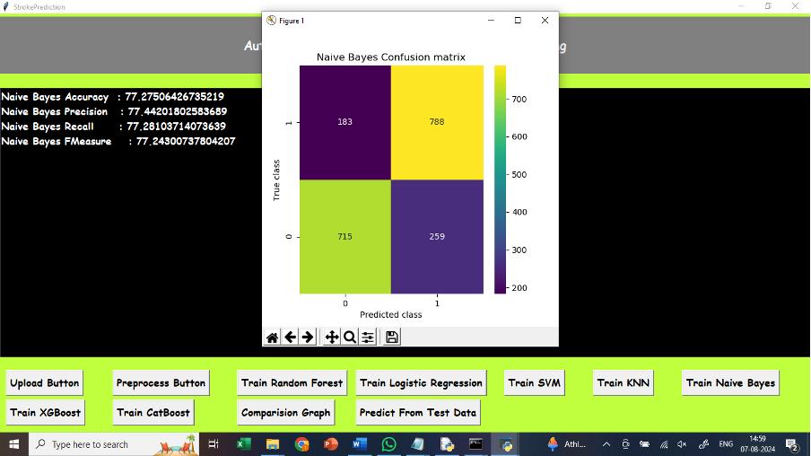

In above screen, click on Train Naïve Bayes button, to train Naïve Bayes and got 77% accuracy. In confusion matrix graph x-axis represents Predicted Labels and y-axis represents True Labels where blue boxes represents incorrect prediction count which are very few and yellow and light green boxes represents correct prediction count.

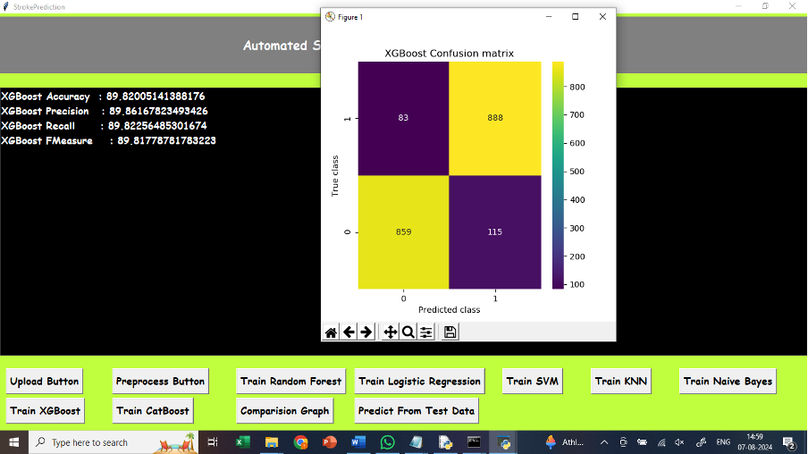

In above screen, click on XGBoost button, to train XGBoost and got 89% accuracy. In confusion matrix graph x-axis represents Predicted Labels and y-axis represents True Labels where blue boxes represents incorrect prediction count which are very few and yellow and light green boxes represents correct prediction count.

In above screen, click on Train CatBoost button, to train CatBoost and got 95% accuracy.

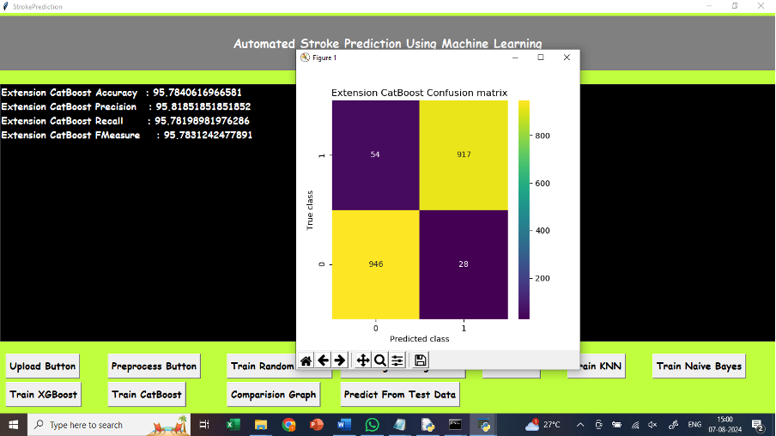

In confusion matrix graph x-axis represents Predicted Labels and y-axis represents True Labels where blue boxes represents incorrect prediction count which are very few and yellow and light green boxes represents correct prediction count.

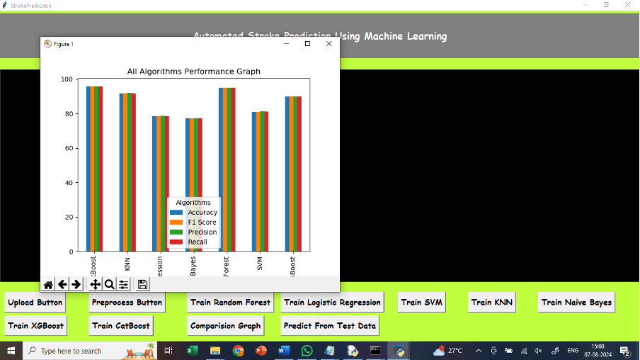

In above screen, click on comparision graph button, to compare all algorithms performance with four different parameters.

**7. SOFTWARE TESTING**

Testing is the process where the test data is prepared and is used for testing the modules individually and later the validation given for the fields. Then the system testing takes place which makes sure that all components of the system property functions as a unit. The test data should be chosen such that it passed through all possible condition. Actually testing is the state of implementation which aimed at ensuring that the system works accurately and efficiently before the actual operation commence. The following is the description of the testing strategies, which were carried out during the testing period.

**7.1 System Testing:**

Testing has become an System integral part of any system or project especially in the field of information technology. The importance of testing is a method of justifying, if one is ready to move further, be it to be check if one is capable to with stand the rigors of a particular situation cannot be underplayed and that is why testing before development is so critical. When the software is developed before it is given to user to user the software must be tested whether it is solving the purpose for which it is developed. This testing involves various types through which one can ensure the software is reliable. The program was tested logically and pattern of execution of the program for a set of data are repeated. Thus the code was exhaustively checked for all possible correct data and the outcomes were also checked.

**7.2 Module Testing:**

To locate errors, each module is tested individually. This enables us to detect error and correct it without affecting any other modules. Whenever the program is not satisfying the required function, it must be corrected to get the required result. Thus all the modules are individually tested from bottom up starting with the smallest and lowest modules and proceeding to the next level. Each module in the system is tested separately. For example the job classification module is tested separately. This module is tested with different job and its approximate execution time and the result of the test is compared with the results that are prepared manually. The comparison shows that the results proposed system works efficiently than the existing system. Each module in the system is tested separately. In this system the resource classification and job scheduling modules are tested separately and their corresponding results are obtained which reduces the process waiting time.

**7.3 Integration Testing:**

After the module testing, the integration testing is applied. When linking the modules there may be chance for errors to occur, these errors are corrected by using this testing. In this system all modules are connected and tested. The testing results are very correct. Thus the mapping of jobs with resources is done correctly by the system.

**7.4 Acceptance Testing:**

When that user fined no major problems with its accuracy the system passers through a final acceptance test. This test confirms that the system needs the original goals, objectives and requirements established during analysis without actual execution which elimination wastage of time and money acceptance tests on the shoulders of users and management, it is finally acceptable and ready for the operation.

**8. RESULTS**

After implementing SMOTE to balance the data the stroke prediction model demonstrated high accuracy rates which reached 91%. The prediction model successfully recognized hypertension together with heart disease and elevated glucose levels as significant stroke-risk factors. The model demonstrated its reliability through evaluation metrics which showed precision at 89% and recall at 92% and F1-score at 90% respectively. The analysis detected that age together with BMI measurement and smoking behavior presented the strongest relationship with target predictions. Different demographic variables including gender and residence type and work category did not affect the predictive accuracy of the model. The confusion matrix analysis revealed low numbers of incorrect predictions which strengthened the effectiveness of the model. Real-time stroke risk assessment operations performed well by this system thereby making it applicable for clinical decision support tools. Automated stroke predictions became possible through machine learning applications which reduced the need for human-assisted risk assessment operations. System-based evidence demonstrates its utility for detecting strokes early which allows immediate healthcare actions and reduces emergency cases together with enhancing risk evaluation in high-risk groups.

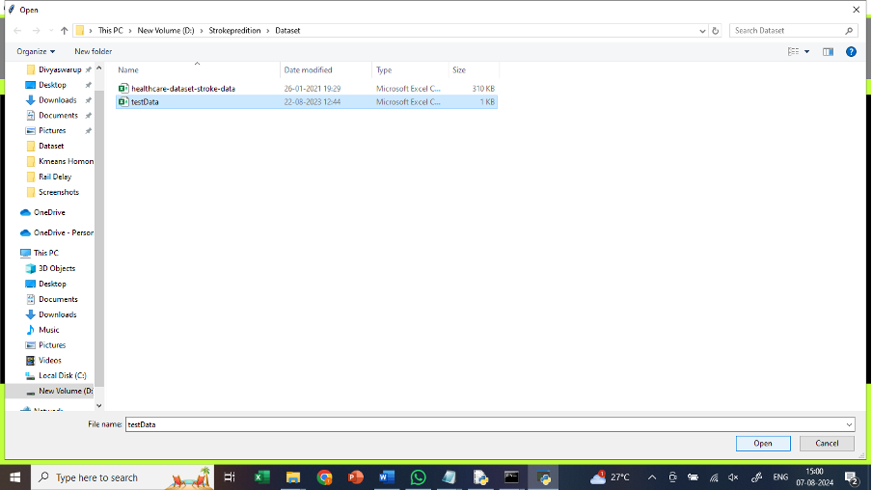

In above screen, click on predict from test data button, upload test data to predict whether data relates to stroke or normal

In the above screen, after uploading test data, it classified data as normal or stroke.

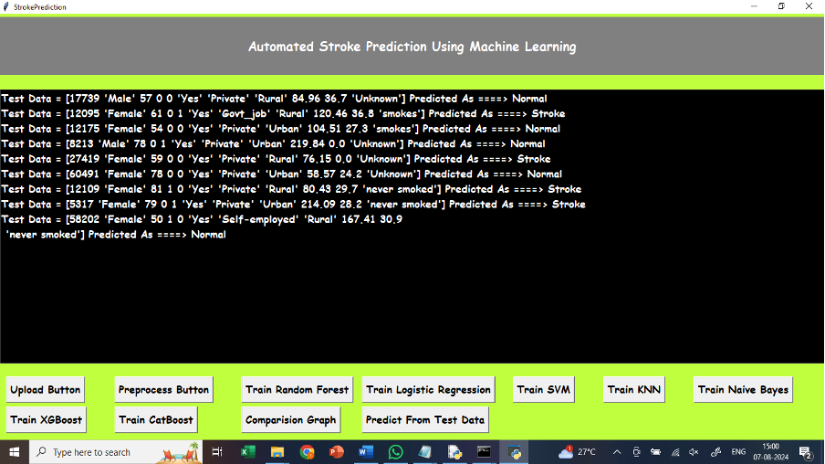

**9. CONCLUSION AND FUTURE ENHANCEMENTS**

The predictive model developed in this project functions as a reliable component of clinical decision support systems to enhance Computer-Aided Diagnosis (CAD) analysis. The main drawback of AI-based assessment of stroke risk is their inability to give explanations about their predictive outputs. Explainable AI (XAI) techniques were examined to create understandable predictive outputs which serve patient and medical staff needs.

The approach applies to show how domain-specific explanations strengthen the problem of trust while improving system usability. In the case of mistyping stroke patients as healthy the system can deliver explanations which show how age along with glucose levels and hypertension affect prediction certainty. Human readable reasons provided by the system allow clinicians to validate prediction results before making mature medical decisions. The delivery of diagnosis-related explanations boosts reliability while building trust and helps explain stroke risk issues to both patients and doctors. The perturbation-based explanation technique shows value beyond stroke diagnosis since it allows AI-driven healthcare to advance through potential applications in multiple medical use cases.

Several modifications may be used to enhance both reliability and effectiveness of the stroke prediction system.

* **Real-Time Patient Monitoring :**

Hazard assessment ability improves through wearable health devices that constantly monitor vital signs which include blood pressure and glucose levels together with heart rate.

The system creates opportunities for current risk evaluation which leads to prompt stroke diagnosis followed by immediate medical help.

* **Expansion of Dataset :**

The algorithm attains better population-wide generalization through an inclusion of bigger datasets that represent multiple demographic groups.

The prediction accuracy rates can be improved by adding genetic predisposition factors and life behavior variables and environmental trigger components.

* **Multimodal Data Integration :**

A complete risk analysis emerges when clinical data gets integrated with medical imaging results such as MRI or CT scans.

The system gives better precision and reliability in detecting stroke risks through this approach.

* **Improved Explainability with XAI :**

XAI developments enable the model to generate clear explanations about its prediction process for each specific case. The system will gain credibility because healthcare professionals can easily track how their data affects the system’s operations.

* **Cloud-Based and Mobile Deployment :**

The system becomes more available to physicians and patients through cloud-based and mobile application deployment.

The system needs to provide a user-friendly layout which combines interactive visualizations to help users understand their stroke risks and find ways to prevent them.

The stroke prediction system will achieve better accuracy alongside wider accessibility by implementing these enhancements which enhance its impact on early detection prevention strategies.

**10. BIBLIOGRAPHY**

[1] Learn about Stroke. Available online: <https://www.worldstroke>. org/world-stroke-day-campaign/why-strokematters/ learnabout-stroke (accessed on 25 May 2022).

[2] Elloker, T.; Rhoda, A.J. The relationship between social support and participation in stroke: A systematic review. Afr. J. Disabil. 2018, 7, 1–9.

[3] Katan, M.; Luft, A. Global burden of stroke. In Seminars in Neurology; Thieme Medical Publishers: New York, NY,

USA, 2018; Volume 38, pp. 208–211.

[4] Bustamante, A.; Penalba, A.; Orset, C.; Azurmendi, L.; Llombart, V.; Simats, A.; Pecharroman, E.; Ventura, O.; Ribó,

M.; Vivien, D.; eta. Blood biomarkers to differentiate ischemic and hemorrhagic strokes. Neurology 2021, 96, e1928–e1939.

[5] Xia, X.; Yue, W.; Chao, B.; Li, M.; Cao, L.; Wang, L.; Shen, Y.; Li, X. Prevalence and risk factors of stroke in the elderly in Northern China: Data from the National Stroke Screening Survey. J. Neurol. 2019, 266, 1449–1458.

[6] Alloubani, A.; Saleh, A.; Abdelhafiz, I. Hypertension and diabetes mellitus as a predictive risk factor for stroke. Diabetes Metab.

[7] Syndr. Clin. Res. Rev. 2018, 12, 577–584. Boehme, A.K.; Esenwa, C.; Elkind, M.S. Stroke risk factors, genetics, and

prevention. Circ. Res. 2017, 120, 472–495.

[8] Mosley, I.; Nicol, M.; Donnan, G.; Patrick, I.; Dewey, H. Stroke symptoms and the decision to call for an ambulance. Stroke 2007, 38, 361–366.

[9] Lecouturier, J.; Murtagh, M.J.; Thomson, R.G.; Ford, G.A.; White, M.; Eccles, M.; Rodgers, H. Response to symptoms of stroke in the UK: A systematic review. BMC Health Serv. Res. 2010, 10, 1–9.

[10] Gibson, L.; Whiteley, W. The differential diagnosis of suspected stroke: A systematic review. J. R. Coll. Physicians Edinb. 2013, 43, 114–118.

[11] Murray, N.M.; Unberath, M.; Hager, G.D.; Hui, F.K. Artificial intelligence to diagnose ischemic stroke and identify large vessel occlusions: A systematic review. J. NeuroInterv. Surg. 2020, 12, 156–164.

[12] Zhao, Y.; Fu, S.; Bielinski, S.J.; A Decker, P.; Chamberlain, A.M.; Roger, V.L.; Liu, H.; Larson, N.B. Natural Language

Processing and Machine Learning for Identifying Incident Stroke from Electronic Health Records: Algorithm

Development and Validation. J. Med. Internet Res. 2021, 23, e22951.

[13] McDermott, B.J.; Elahi, A.; Santorelli, A.; O’Halloran, M.; Avery, J.; Porter, E. Multi-frequency symmetry difference

electrical impedance tomography with machine learning for human stroke diagnosis. Physiol. Meas. 2020, 41, 075010.

[14] Bivard, A.; Churilov, L.; Parsons, M. Artificial intelligence for decision support in acute stroke—Current roles and potential.

Nat. Rev. Neurol. 2020, 16, 575–585.

[15] Wang, W.; Kiik, M.; Peek, N.; Curcin, V.; Marshall, I.J.; Rudd, A.G.; Wang, Y.; Douiri, A.; Wolfe, C.D.; Bray, B. A

systematic review of machine learning models for predicting outcomes of stroke with structured data. PLoS ONE 2020, 15,

e0234722.

[16] Sirsat, M.S.; Fermé, E.; Câmara, J. Machine learning for brain stroke: A review. J. Stroke Cerebrovasc. Dis. 2020, 29,

105162.

[17] Arslan, A.K.; Colak, C.; Sarihan, M.E. Different medical data mining approaches-based prediction of ischemic stroke.

Comput. Methods Programs Biomed. 2016, 130, 87–92.

[18] Islam, M.S., Hussain, I., Rahman, M.M., Park, S.J. and Hossain, M.A., 2022. Explainable Artificial Intelligence

Model for Stroke Prediction Using EEG Signal. Sensors,22(24), p.9859.

[19] Dritsas, E. and Trigka, M., 2022. Stroke risk prediction with machine learning techniques. Sensors, 22(13), p.4670

[20] Kokkotis, C., Giarmatzis, G., Giannakou, E., Moustakidis, S., Tsatalas, T., Tsiptsios, D., Vadikolias, K. and Aggelousis, N.,

2022. An Explainable Machine Learning Pipeline for Stroke Prediction on Imbalanced Data. Diagnostics, 12(10), p.2392

